**HOME PAGE FOR JOIN**

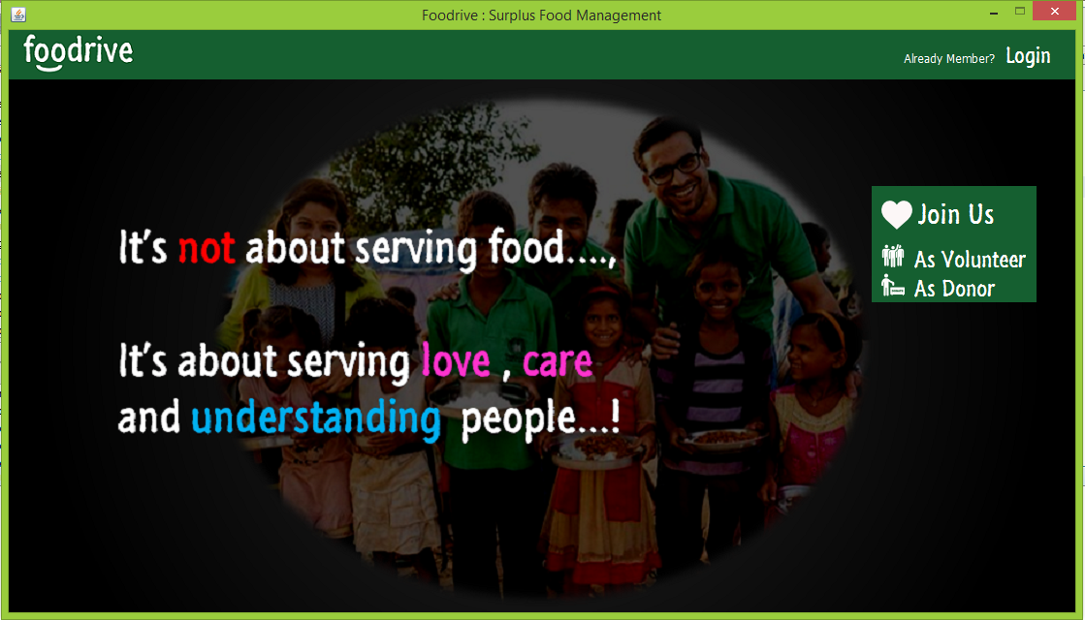

**JOIN FOR VOLUNTEER**

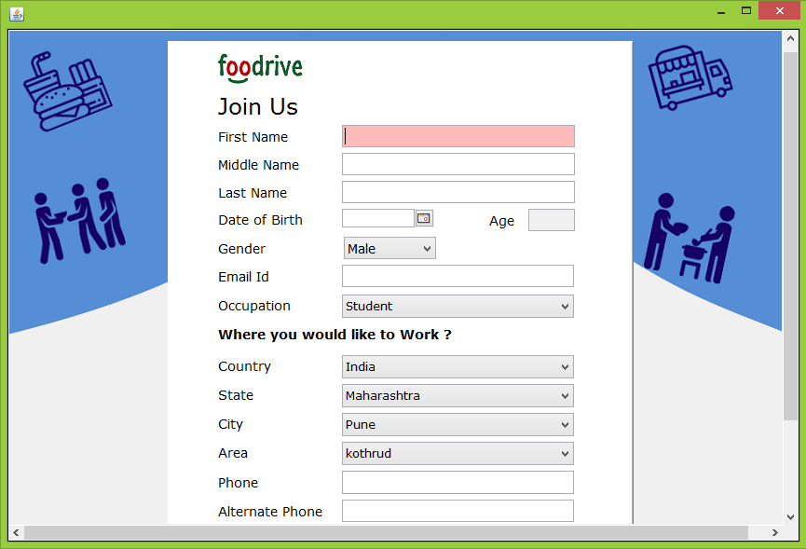

**JOIN FOR DONOR**

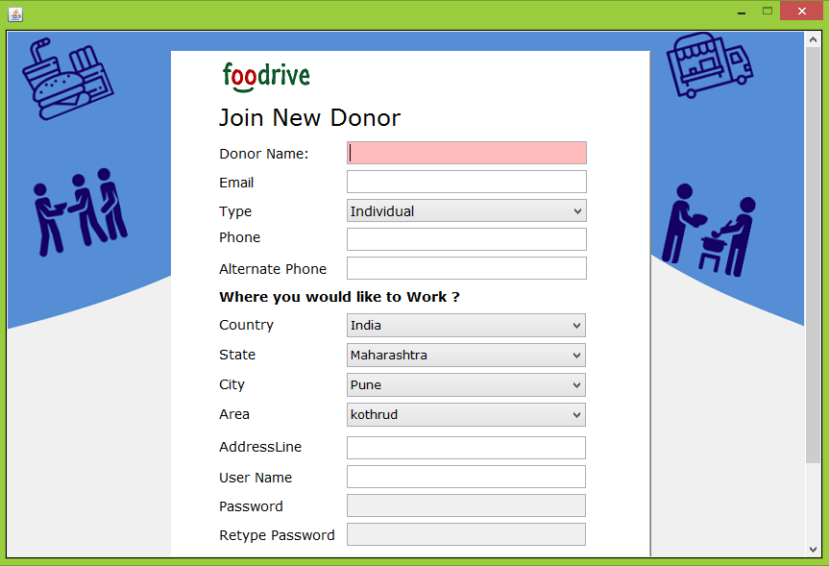

**LOGIN**

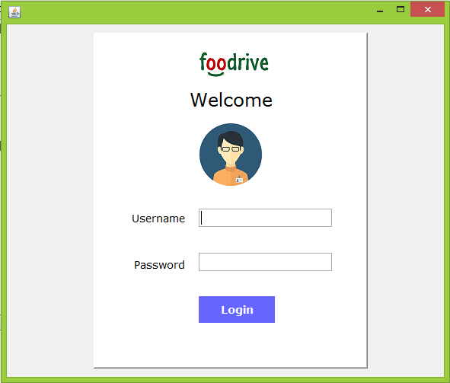

**LOGIN FAILURE VALIDATION:**

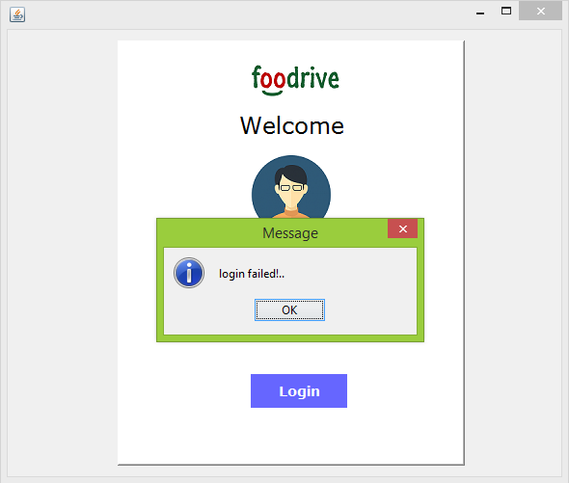

**MONITOR DASHBOARD**

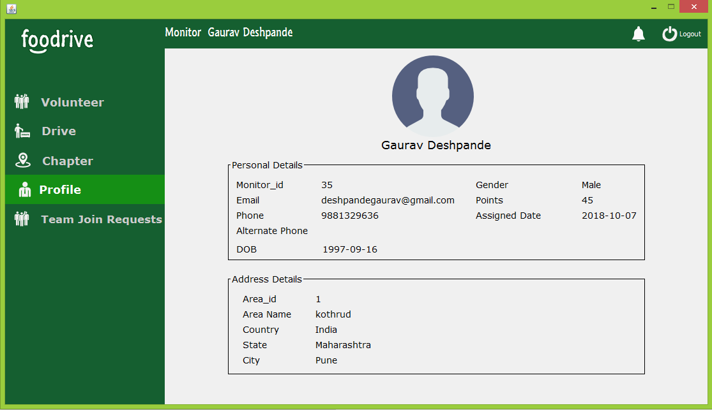

**MONITOR DRIVE VIEW**

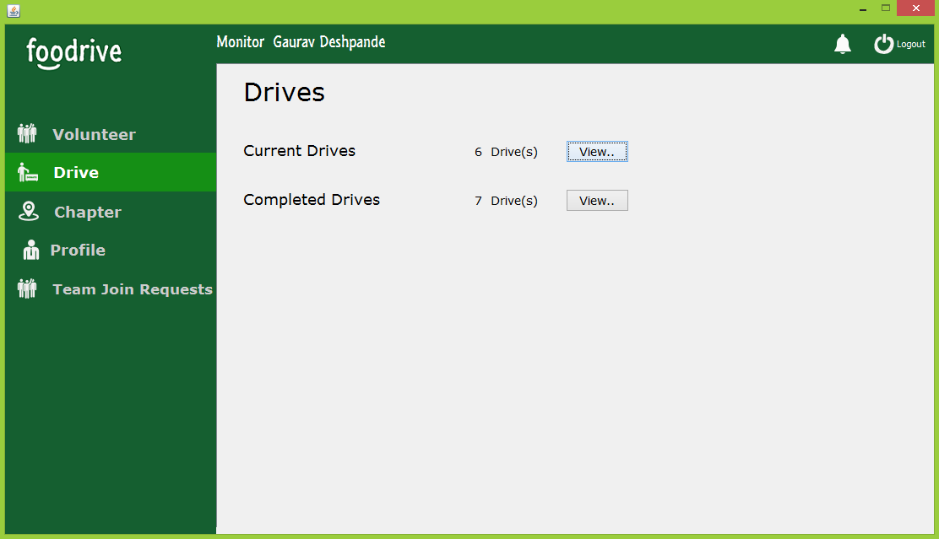

**MONITOR IN CURRENT DRIVE**

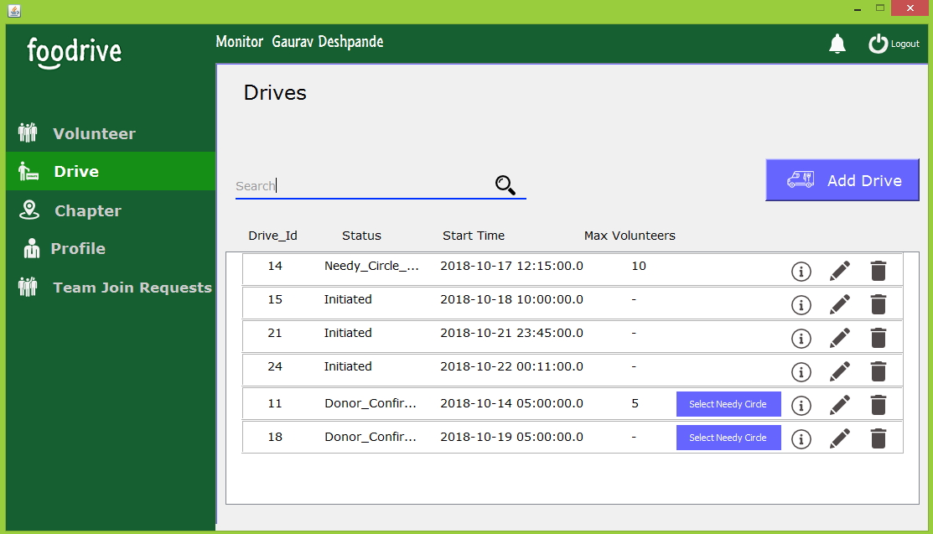

**MONITOR ADD DRIVE**

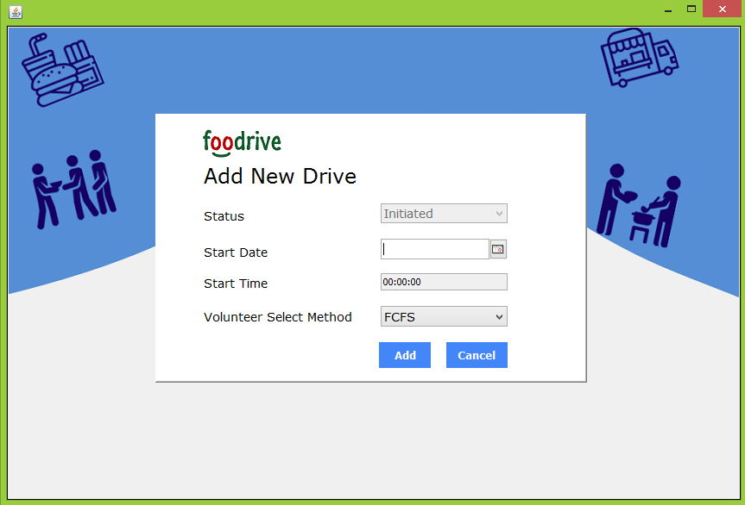

**DONOR DASHBOARD**

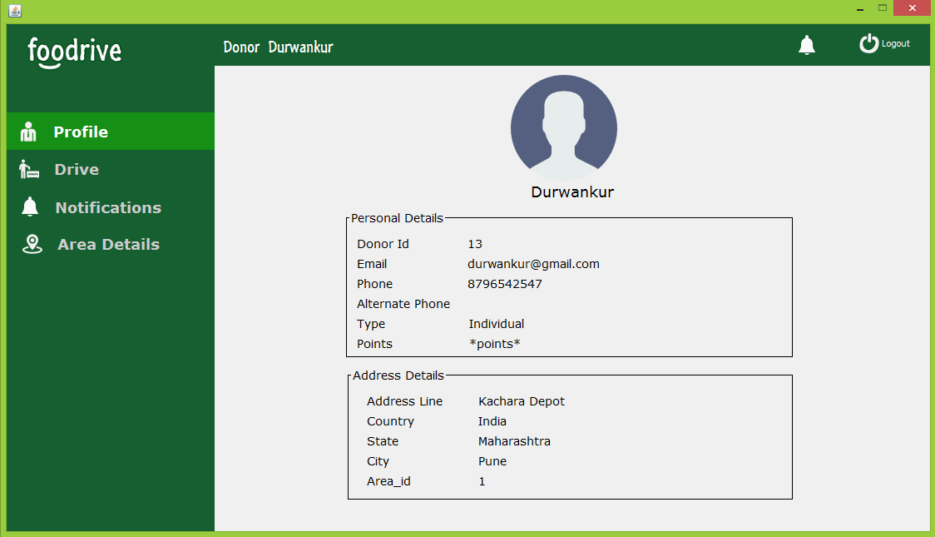

**DONOR IN DRIVE**

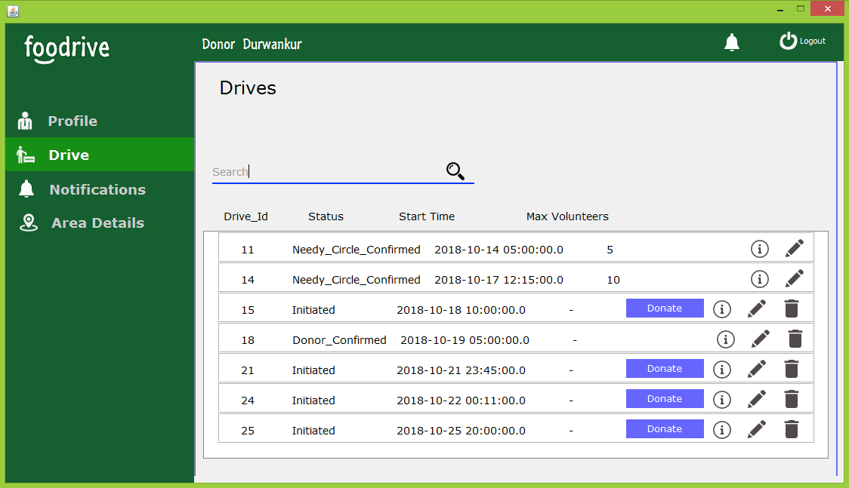

**DONOR DONATE FOOD**

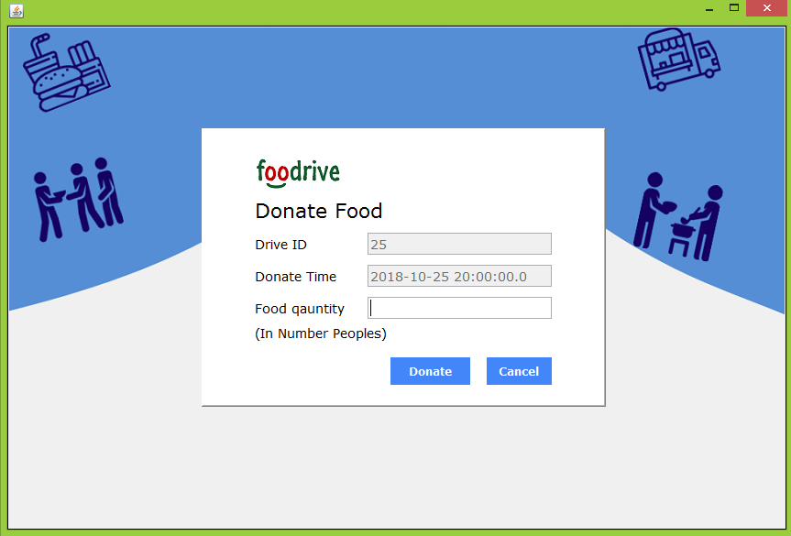

**DONATION CONFIRMED**

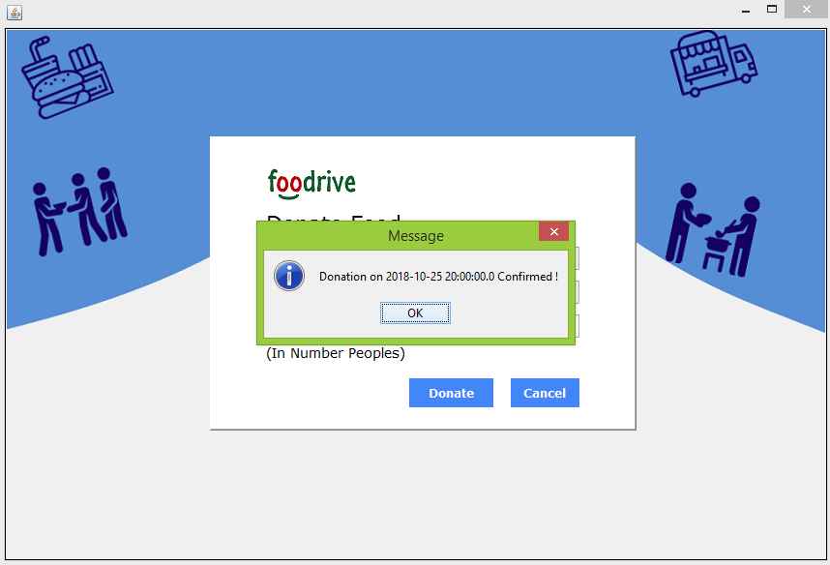

**MONITOR SELECT NEEDT CIRLE**

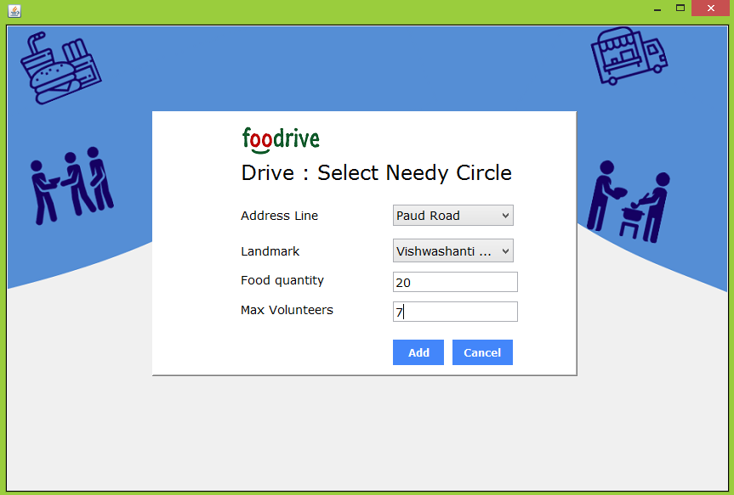

**VOLUNTEER DASHBOARD**

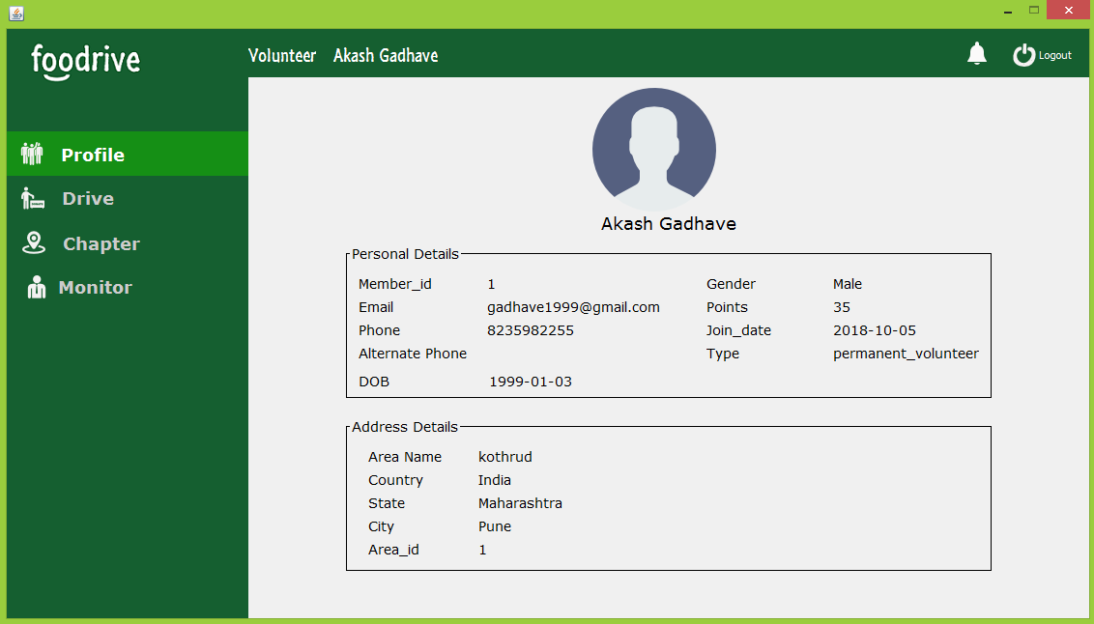

**VOLUNTEER DRIVE VIEW**

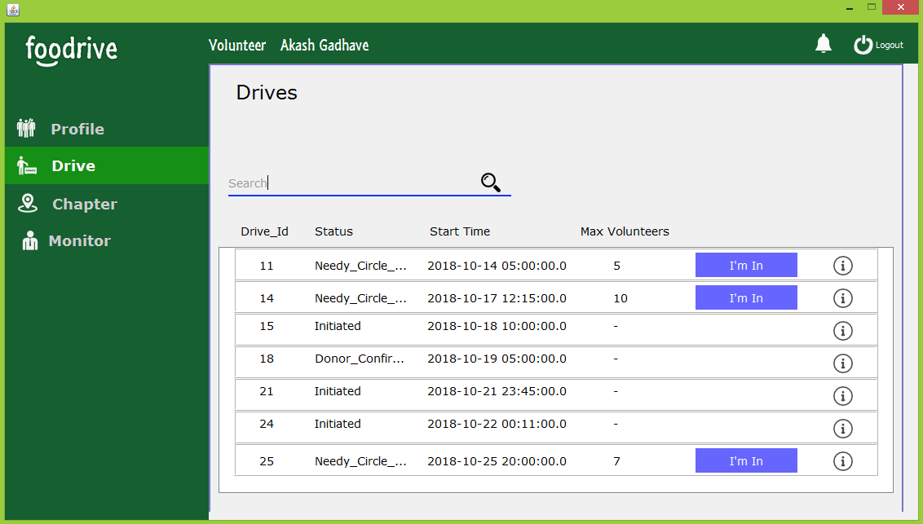

**AFTER VOLUNTEER IN**

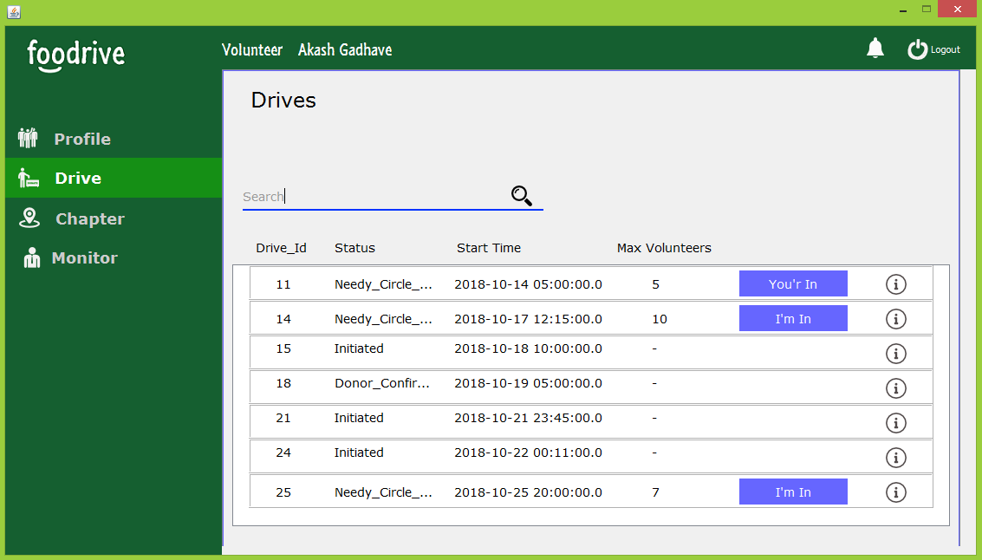

**DISTRIBUTE FOOD**

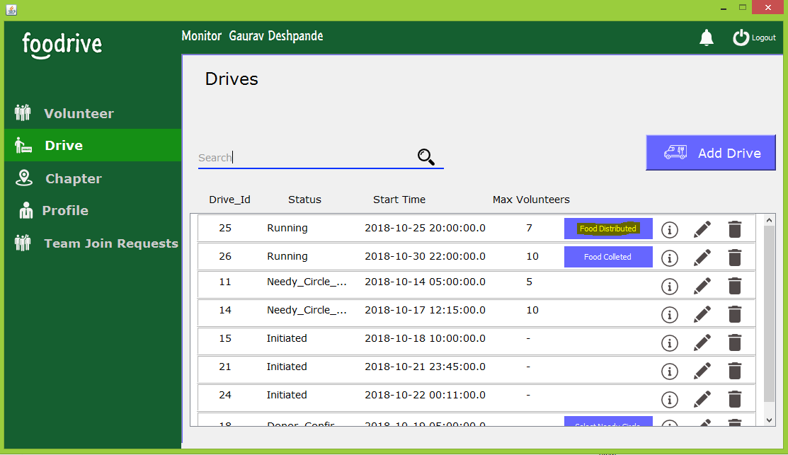

**AFTER VOLUNTEER’s INTEREST**

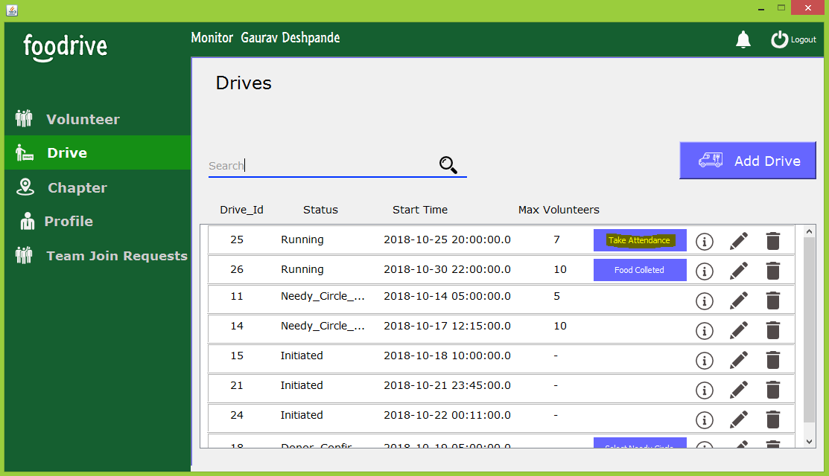

**ATTENDACE VIEW OF DONOR**

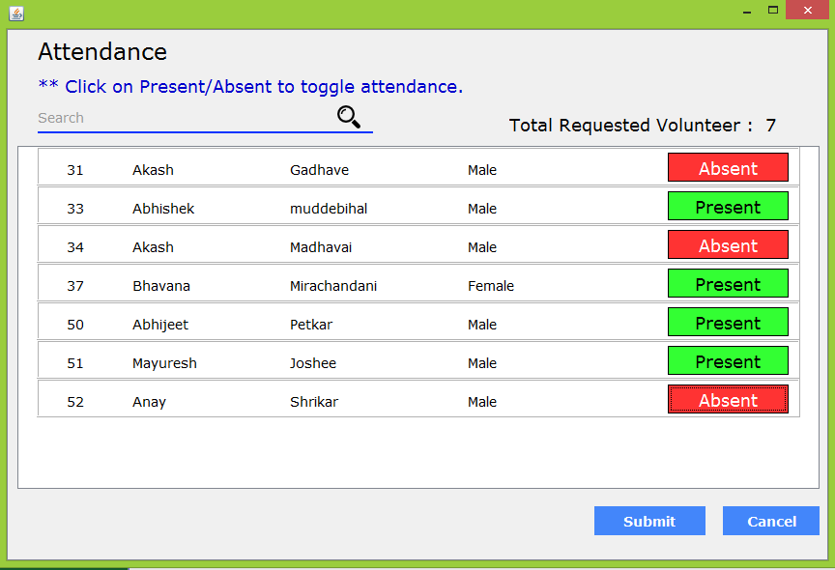

**AFTER SUBMIT ATTENDANCE**

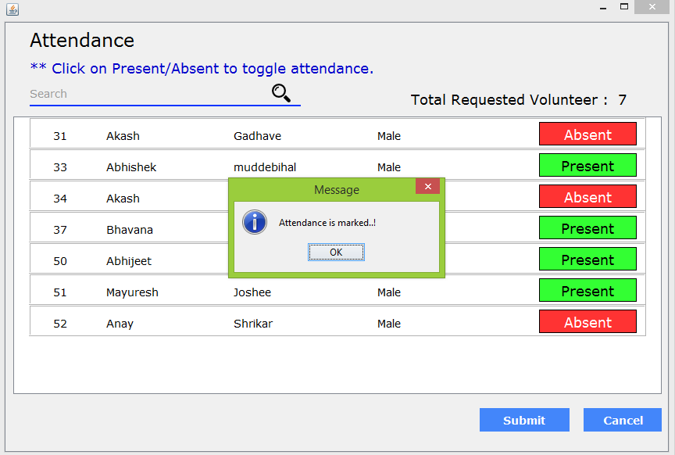

**FINISH DRIVE**

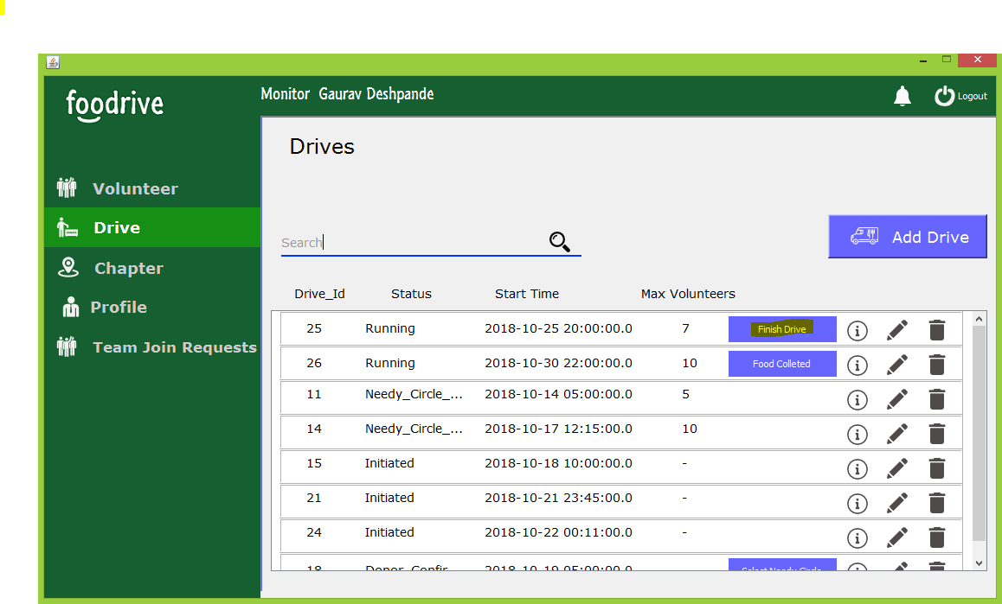

**DRIVE FINISHED**

